
Assignment # 01
Student Name: | FARHAT NAZ
Registration ID: | 844005
Course Code: | 8611
Semester: | Spring 2026

Q.1: Why in human civilizations do critical thinkers challenge the status quo?
Critical thinkers play a vital role in the evolution of human societies by questioning established norms and practices. Their insights often lead to significant societal advancements, influencing perspectives on governance, culture, and education.
Role of Critical Thinkers
Critical thinkers analyze and assess societal constructs, aiming to improve and innovate.
History of Challenges
Throughout history, critical thinkers have sparked revolutions, reformed societies, and inspired change.
Characteristics of Critical Thinkers
They possess traits such as curiosity, skepticism, and open-mindedness, allowing for deep examination of beliefs.
Impact on Society
Challenging the status quo leads to progress, whether in human rights, science, or cultural practices.
Paradox of Change
While critical thinkers propose changes, they face resistance from those benefiting from the status quo.
Examples in Civilizations
Figures like Socrates, Kant, and contemporary activists exemplify challenging established norms.
Value in Education
Education systems often rely on critical thinkers to evolve curricula and teaching methodologies.
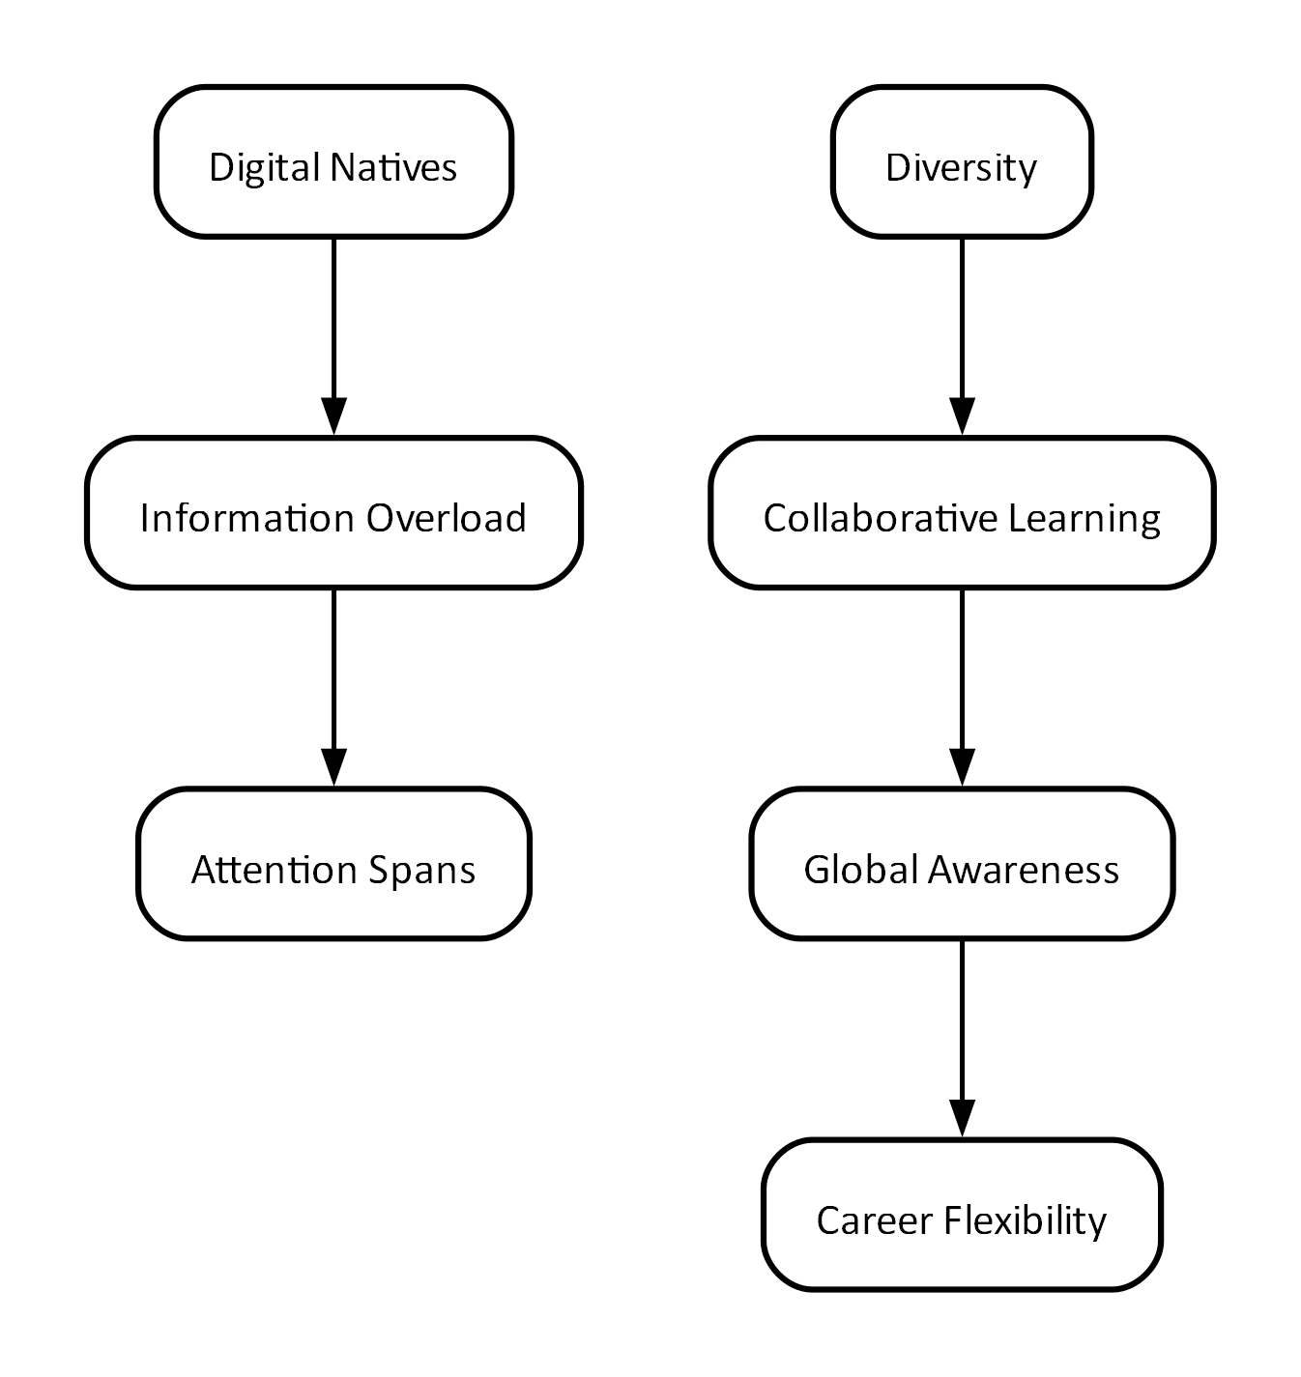
Conclusion
Critical thinkers are essential in challenging the status quo. Their ability to question and innovate fosters growth and improvement within societies, ultimately benefiting humanity as a whole.
Q.2: Why is critical and reflective thinking important for teachers’ professional growth and development?
Critical and reflective thinking are crucial for teachers as they navigate the complexities of education. These processes empower educators to assess their practices, adapt to new challenges, and ultimately enhance student learning outcomes.
Defining Critical Thinking
It involves analyzing and evaluating one’s own teaching practices.
Defining Reflective Thinking
This is a process where educators consider their experiences to improve future practices.
Improving Classroom Practices
Critical reflection aids in identifying effective strategies for diverse learners.
Facilitating Professional Development
Engaging in critical discussions promotes growth among teaching peers.
Adapting to Change
Reflective thinking helps educators respond to evolving educational technologies and methodologies.
Fostering Student Engagement
Teachers who reflect critically often create more engaging and relevant learning environments.
Nurturing Lifelong Learning
Critical reflection encourages a mindset of ongoing professional development.

Conclusion
Critical and reflective thinking are vital for teachers’ growth and professional development. By engaging in these processes, educators can enhance their teaching abilities, adapt to changes, and better serve their students.
Q.3: How do you see the theories of Paulo Freire and Pierre Bourdieu applicable in Pakistan?
The educational theories of Paulo Freire and Pierre Bourdieu provide valuable lenses through which the educational realities of Pakistan can be understood. Both theorists emphasize the importance of social context in education and critique established power structures.
Context of Freire's Theory
Freire advocates for education that stimulates critical consciousness, allowing learners to challenge oppression.
Context of Bourdieu's Theory
Bourdieu focuses on the relationship between education and social inequality, highlighting cultural capital's role.
Challenges in Pakistan
Educational disparities and entrenched social hierarchies in Pakistan reflect these theorists' concerns.
Relevance of Freire's Pedagogy
Freire's approach enables marginalized groups to reclaim their narrative and foster empowerment.
Bourdieu's Cultural Capital
Understanding social dynamics can help educators recognize the barriers faced by students from different backgrounds.
Application in Curriculum Development
Both theories can inform the creation of curricula that address social issues and promote equity.
Potential for Societal Change
Implementing these theories could spark broader societal awareness and reform.

Conclusion
The theories of Freire and Bourdieu address critical issues in Pakistan's education system, offering frameworks for empowering marginalized communities and promoting social equity.
Q.4: Think of your own learning experiences and write a critical review of classroom instructional practices in schools
Personal learning experiences offer profound insights into instructional practices that can enhance or hinder educational outcomes. A critical review of classroom methods must consider both the effectiveness and the impact on student engagement and learning.
My Learning Background
Reflecting on various classrooms, experiences varied significantly in instructional methods employed.
Effective Practices
Active learning strategies, such as group work and discussions, fostered deeper understanding.
Ineffective Practices
Lecture-based approaches often led to disengagement and superficial understanding.
Teacher's Role
Facilitators who observed, assessed, and adapted practices generally resulted in better student engagement.
Feedback and Assessment
Constructive feedback is crucial; it guides learners and enhances their understanding.
Integration of Technology
Technology, when integrated well, improved accessibility and engagement.
Cultural Responsiveness
Culturally relevant teaching methods were more effective in engaging diverse learners.

Conclusion
Critical reflections on classroom practices reveal a mixture of successes and failures, emphasizing the need for adaptive and responsive instructional strategies to bolster student engagement and learning.
Q.5: How do you see the learners of this generation different from all previous generations?
The current generation of learners exhibits distinct characteristics that set them apart from previous cohorts. Understanding these differences is essential for adapting educational practices and preparing students for an increasingly complex world.
Digital Natives
Learners grow up with technology, impacting their learning habits and accessibility.
Information Overload
Access to information is unprecedented, requiring critical thinking to discern quality.
Diversity and Inclusion
Today’s learners are more diverse, necessitating inclusive teaching practices.
Collaborative Learning
There is a greater emphasis on teamwork and collaboration in learning environments.
Shorter Attention Spans
The digital age has contributed to reduced attention spans, demanding engaging pedagogies.
Global Awareness
Learners are more in tune with global issues, urging a cosmopolitan approach in education.
Career Flexibility
Current learners seek not just traditional career paths but diverse opportunities.

Conclusion
Today's learners differ significantly from past generations in their digital fluency, diversity, and expectations, prompting a need for educational systems to evolve in response.

